Main Menu

Hew Lines VA7HU

1.0 GENERAL

Logger32 utilizes two standard Windows Menu bars, the Main Menu and Setup Menu.

The Main Menu consists of seven menu items that enable the user to access the following functionality:

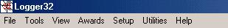

MM_1

2.0 FILE MENU ITEM

The FILE menu item allows the user to:

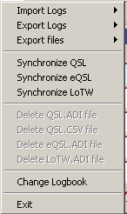

MM_2

  - Import logs in ADIF (.ADI) format;

MM_3

  - Export logs in the following formats:

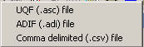

MM_4
    - UQF (.ASC);
    - ADIF (.ADI); and,
    - Comma Delimited (.CSV).
  - Export files in the following formats:

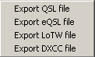

MM_5
    - QSL;
    - eQSL;
    - LoTW; and,
    - DXCC.
  - Synchronize paper QSLs;
  - Synchronize your eQSL records;
  - Synchronize your LoTW records;
  - Delete your QSL.ADI file:

  - Delete your QSL.CSV file;
  - Delete your eQSL.ADI file;
  - Delete your LoTW.ADI file;
  - Change your logbook; and,
  - Exit Logger32.

3.0 TOOLS MENU ITEM
The TOOLS menu item allows the user to:

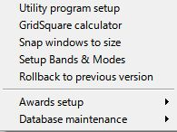

MM_6

  - Setup Logger32 to use external applications such as QSL Printing programs, WordPad, Notepad, etc.
  - Utilize the Grid Square Calculator;
  - Snap windows to size;
  - Setup Bands & Modes;
  - Rollback to previous version
If you have a problem after an update then you can rollback to the previously used version saved in the rollback folder. See details in the Updating Logger32 topic.
  - Setup and track various awards:
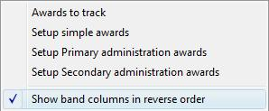

MM_7
    - Select the Awards they wish to track;

    - Setup Simple Awards;

    - Setup Primary Administration Awards; and,

    - Setup Secondary Administration Awards.
    - Show band columns in reverse order

  - Configure and maintain Database tables and QSO numbers:

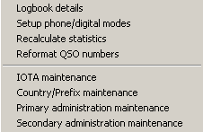

MM_8

    - Display Logbook details;

    - Setup phone and digital modes;

    - Recalculate statistics;

    - Reformat QSO numbers;

    - Maintain the IOTA database;

    - Maintain the Country/Prefix database;

    - Maintain the Primary Administration database; and,

    - Maintain the Secondary Administration database.

4.0 VIEW MENU ITEM

The VIEW menu item allows the user to:

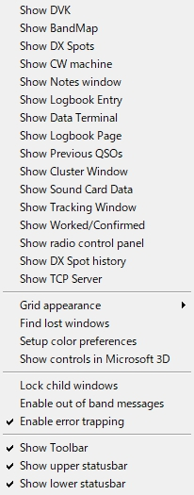

new MM_9

  - Display the Digital Voice Keyer (DVK);

  - Display the BandMap;

  - Display the DX Spots window;

  - Display the CW machine;

  - Display the Notes and Comments window;

  - Display the Logbook Entry window;

  - Display the Data Terminal window;

  - Display the Logbook Page window;

  - Display the Previous QSOs window;

  - Display the Telnet Cluster WIndow;

  - Display the Sound Card Data window;

  - Display the Tracking Window;

  - Display the Worked/Confirmed window;
  - Display the Radio Control Panel;
  - Display DX Spot History;

  - Display TCP Server window;

  - Modify the Grid appearance:
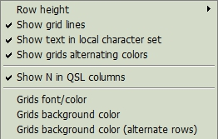

MM_10

    - Set the Row Height;
    - Display Grid Lines;
    - Show text in local character set;

Bob's note:

Logger32 uses the NAME and QTH field defined in the ADIF spec. Not NAME_INTL and not QTH_INTL. By definition, these fields must have ascii characters in the range of 32 through 126.

Should the user import data (or enter it) with characters outside the defined range. They will not show as expected. Names like Stanis³aw will be displayed. The simple solution to the users self-induced problem would be to enable the Logger32 Windows to show local regional characters (a violation of the ADIF spec), but more pleasing to the eye.

Unfortunately, while this makes Eastern European user happy, Asian users do not want local character sets enabled because the Microsoft Fonts using local character sets, are a little disappointing.

So, in an effort to keep everyone happy, look under VIEW | GRID APPEARANCE for a new menu option.
    - DIsplay the Grid in alternating colors;
    - Show the letter N in QSL columns; and,
    - Change the Grids colors.

  - Find any Lost windows

  - Setup color preferences.

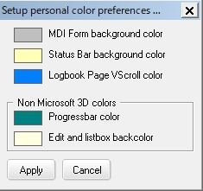

MM_10A

This menu item allows the user to select colors from the color pallet to be used for:

    - The MDI Form background color;

    - The Status Bar background color;

    - Logbook Page VScroll ccolor;

    - Progress Bar colors; and,

    - Edit and Listbox background colors.

  - Show controls in Microsoft 3D. This menu item changes the display characteristics of all Checkboxes, Editboxes, Listboxes, and Date Selection boxes. With this menu item enabled, check marks in the Checkboxes will be displayed in black, and 3D shadows will be created in the other controls. With this item disabled, check marks will be displayed in red, and no shadows will be shown in other controls;

  - Lock child windows. Checking this menu item will lock a child window at its current position so it cannot be moved accidentally;

  - Enable or disable Out-of-Band messages;
  - Enable or disable Error Trapping;

  - Display or Hide the Toolbar;

  - Display or Hide the upper Statusbar; and,

  - Display or Hide the lower Statusbar.

5.0 AWARDS MENU ITEM

The AWARDS menu item enables the operator to create and display the Award table data:

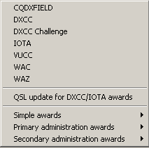

MM_11

  - CQDXFIELD;

  - DXCC;

  - DXCC Challenge;

  - IOTA;

  - VUCC;

  - WAC;

  - WAZ;

  - QSL Update for DXCC/IOTA awards;

  - Simple awards:

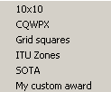

MM_12

    - 10x10;
    - CQWPX;
    - Grid squares;
    - ITU Zones;
    - SOTA; and,
    - Create your own Custom Awards.

  - Primary administration Awards. Currently only WAS; and,

  - Secondary administration Awards. Currently only USACA.

6.0 SETUP MENU ITEM

The SETUP menu item switches the Logger 32 Menu bar to the Setup Menu;

7.0 UTILITIES MENU ITEM

The UTILITIES menu item allows the user to:

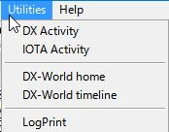

MM_13

  - Display DX Activity from the 425DX Organization;

  - Display IOTA activity from the RSGB;
  - Display DX-World Home;

  - Display the DX-World timeline; and,

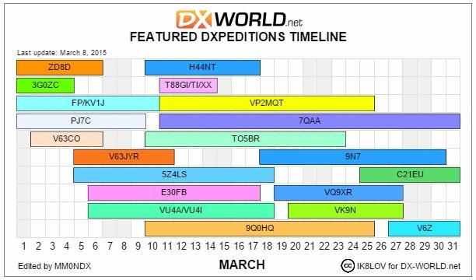

MM_13A

  - Shell out to external programs such as QSL printing software, WordPad, Notepad, and others. These programs are installed by selecting the Tools | Utility Program Setup menu item.

8.0 HELP MENU ITEM
The HELP menu item allows the user to display the:

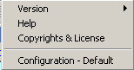

MM_14

  - Logger32 Version Number;

MM_15

  - Helpfile contents;

  - Copyrights and License Helpfile topic; and,

  - Current INI File in use.

